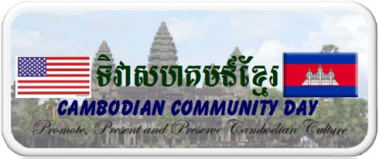 | EXHIBITOR REGISTRATION/UNDERSTANDING FORM FOR  CAMBODIAN COMMUNITY DAY FESTIVAL  SUNDAY August 25th, 2019  Cambodian Buddhist Temple  13800 New Hampshire Ave Silver Spring, MD 20904

TYPE OF EXHIBIT: __ ARTS/CRAFTS __ COMMERCIAL __ INFORMATION/EDUCATION

NAME OF EXHIBIT: ________________________________________________________________________________

CONTACT: _________________________________________________________________________________________

ADDRESS: _________________________________________________________________________________________

CITY: _________________________________________STATE:________ ZIP CODE:_________________________

HOME PHONE: ( _____ ) ______________________ WORK PHONE: ( ______) _____________________________

E-MAIL ADDRESS:__________________________________________________________________________________

WILL ANYTHING BE SOLD AT EXHIBIT? __ YES __ NO. (SEE FEE SECTION BELOW).

LIST ITEMS TO BE SOLD OR INFORMATION ON DISPLAY AND DESCRIBE HOW THEY RELATE TO THE CULTURE OF THE SPECIFIC FESTIVAL: ______________________________________________________________________________________________________________________________________________________________________________________________________________________________________________________________________________
(Use additional sheet of paper if necessary)

NOTE: You are encouraged to attach photos of arts and/or crafts items or of the booth. Photos will not be returned; they will be attached to application for review. Be sure to include a detailed list of all items to be sold or information to be exhibited.

Exhibition Fee:
[ ] $150, if selling product/service
[ ] $50 information and/or education only
[ ] Free for non-profit (proof is required).

You will have to set up/bring down your tent, tables and chairs specific to your need. They may be available at the temple. But you need to do it yourself. We do not have a manpower to do it for you.

Signature: _________________________________________________ Date: __________________________

Make Check Payable and return to:
Cambodian Community Day
12739 Knightsbridge Dr, Woodbridge VA 22192

For CCD Use Only:
Check Number: _________ Amount: $_______________ Date: ___________________

